**BUDDHA SENSOR**

To: Jason Loeb

125 Atlantic Street

Quincy, MA 02171

From: Elisha Tam

20800 Boyce Lane

Saratoga, CA 95070

**Shipped Supplies**

1. 1 cardboard container (blow dryer box), containing Arduino, green perfboard, & relay, 5 load cell amplifier boards
   1. Be very careful when removing this from the box and bag. Try to pull the cardboard and not the wires.
   2. The fuse cable is taped to the bottom of the cardboard mat. You can remove the tape to free the fuse cable
2. 1 white box, containing the 12V DC Power Adapter 2.1mm 1A (to power the Arduino)
3. 1 cardboard box, containing the 12V DC Power Adapter 2A (to power the magnetic lock) + 1 connector
4. 5 scales
   1. 4 wires of each scale are taped inside the scale for protection. You can remove the tape.

**Demo on Youtube**

Component Introduction: <https://youtu.be/nYKxuLt1_iM>

Weight Puzzle Power Up: https://youtu.be/TLgMqSTYA1w

Weight Puzzle Demo: <https://youtu.be/K7c_nsLuTCs>

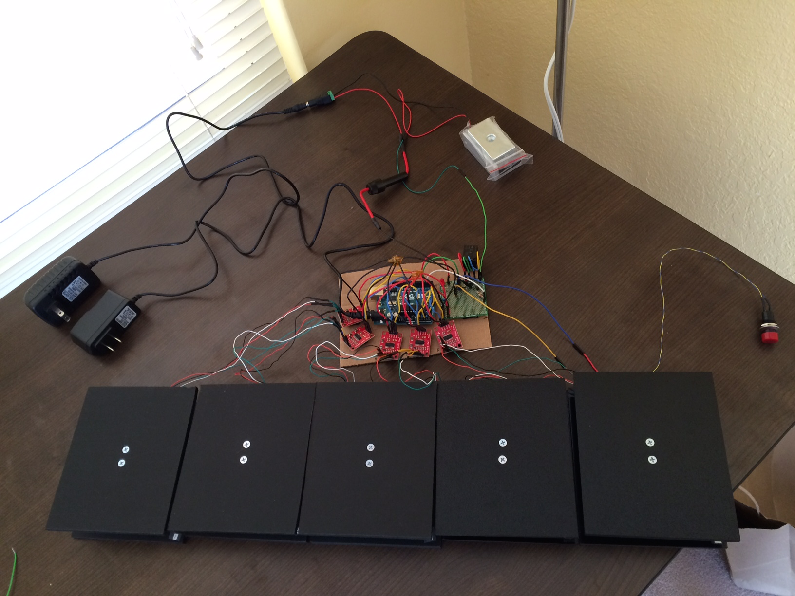

**Electrical Setup**

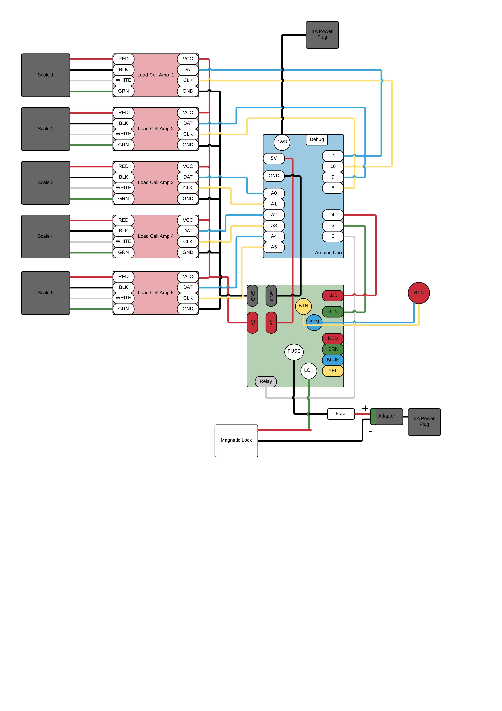

1. There are a lot of connections involved. Elisha would be happy to walk you through this setup over FaceTime and before you plug any components to power.
2. Follow the diagram to connect the 5 scales to their respective Load Cell Amplifier. You should only need to connect
   1. The 4 wires of each of the 5 scales
   2. The yellow and blue wire of the button
   3. The fuse
   4. The magnetic lock
      1. Connect the red cable to “LCK” on the green board
      2. Connect the black cable to the NEGATIVE terminal of the adapter
   5. Power to the Arduino
3. Connect the adapter to the 2A power plug
4. Check all connections are secure
5. Make sure nothing is on the 5 scales before you power up the Arduino – the scales tare at power up
6. Plug the 2A Power Plug into an outlet (for the magnetic lock)
7. Plug the 1A Power Plug into an outlet (for the Arduino).

**Software code**

1. Once the Arduino powers on, wait for the red LED to turn on. The lock will be locked.
2. Push the button to set the target weights on the scale. The red LED will now flash every 0.5sec
3. Place your 5 objects on the scale.
4. Push the button to save the target weights. The red LED will now be OFF
5. Remove one or all of the weights to start the game. The red LED will now be ON. The game is ready to play
6. Place the correct weights on the scales. The lock will UNLOCK

**Costs**

|  |  |  |  |
| --- | --- | --- | --- |
|  | **Unit Cost** | **Qty** | **Total** |
| **Mechanical Components** |  |  |  |
| Arduino Uno | 25.81 | 1 | 25.81 |
| SchmartBoard perf board | 5.43 | 1 | 5.43 |
| 12V DC Power Adapter 2.1mm 1A | 5.69 | 1 | 5.69 |
| 12V DC Power Adapter 2.1mm 2A + 2.1mm adapter | 6.22 | 1 | 6.22 |
| Fuse Holder | 2.69 | 1 | 2.69 |
| Nylon washers (x20) | 9.075 | 1 | 9.075 |
| ABS Plastic | 6.26 | 1 | 6.26 |
| M4 Screws | 6.15 | 1 | 6.15 |
| M5 Screws | 7.35 | **1** | 7.35 |
| Magnetic lock (not provided) | 35.99 | 1 | 35.99 |
|  |  |  |  |
|  |  |  |  |
| **Electrical Components** |  |  |  |
| 2N7000 N Channel MOSFET | 0.4 | 1 | 0.4 |
| Diode | 0.5 | 1 | 0.5 |
| JS1-B-5V-F Relay | 1.86 | 1 | 1.86 |
| Load cell - 10kg (22lbs), Straight bar (TAL220) | 6.95 | 5 | 34.75 |
| HX711 amplifier | 9.95 | 5 | 49.75 |
| Push button | 1.96 | 1 | 1.96 |
| Fuse (250V, 1A) | 0.95 | 1 | 0.95 |
|  |  |  |  |
| **Time** |  |  |  |
| Took 10 hrs. 1hr to prepare, 6hrs to implement, 3hrs to clean up and document. | 50 | 10 | 500 |
|  |  |  |  |
| **Shipping** |  |  |  |
| UPS 3Day Shipping |  |  | 47.93 |
| Spark Fun shipping |  |  | 5.63 |
|  |  |  |  |
|  |  | **TOTAL** | 754.395 |